CSES INTERNATIONAL, Inc.
CSES International, Inc. was founded in the fall of 1991 then originally named SE Integrators, Inc. by Michael Relph at the request of my manager at Ford Motor Company while working on the Control System for the 7.3 Liter Powerstroke Diesel Engine development for the 1994 model year.
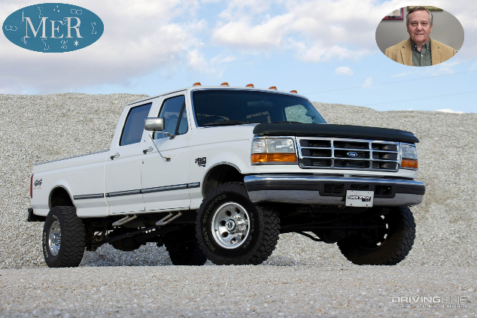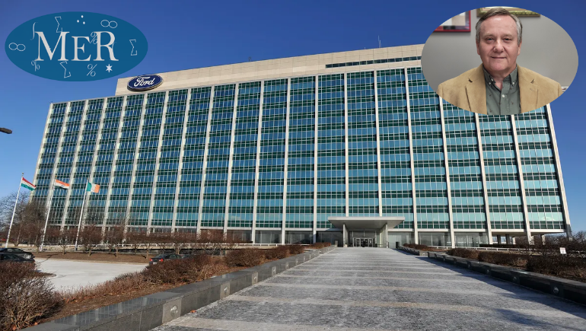
Not sure why I started the company to start with… as several months went by before did anything… until I was asked if I could automate a Women’s and Children’s fashion wear retail store. Located at Ballenger Highway and Flushing Road on the west side of Flint, I said “sure I know about barcodes, scanners and such,” so I got to work. At the time I was also working with my friend Nicholas Blake (whose Grandfather invented the Hydromatic Transmission for General Motors) helping with a small computer store in Clawson asked about Point of Sale Systems, and found one at the very back of the Computer Shopper Magazine from a company named MicroBiz out of New York. I ordered the demo saw it worked easily on an IBM PC even without a manual, and the rest was history.
MicroBiz had trainings for vendors like myself, and offered to sell the source code and development tools and to train you how to customize their application for customers. Being a software developer I was drawn to the opportunity and sold it to Bob Perani of Perani’s Hockey Shops and automated his stores and Warehouse in Flint, Metro Detroit, and Cleveland. Bob was a goalie of the Flint Generals and invented the modern Goalie Protective Gear to include the Helmets used by the Pro’s even today. Working out of his Flint Store on Dort Highway I spent many over night development sessions locked in the store (not a great neighborhood) and leaving in time to get to Dearborn at Ford I would stop at Bob’s home I would put the store key under the mat of his car in the driveway.
Over time Bob introduced me to hockey greats like Yzerman, Gretzky, and a bus load of others as one day many came to the store while I was there to test the BRAND NEW Graphite Hockey Stick. They were wowed by it but knew it wouldn’t fly as the puck was being launched to speeds far beyond where they were then. Some bragged about hitting the puck over 150mph.
At about the same time I was introduced to Larry Burtrum of Furs By Clyde Burtrum in June of 1992. Clyde the founder – 1936, was in the process of handing the store to Larry caught me without Larry standing next to me infactically declaring “we don’t need no computer here” was caught by Larry who pulled his father away saying “don’t mind a VERY OLD MAN, he is scared of them all.” Incidentally it was only blocks away from the Woman’s and Children’s Fashions Shop!! In the end I worked customizing and expanding his systems throughout his whole store even to his home working closely with him from Jul 1992 – Jan 2013.
When one customizes a Point of Sale System you not only learn about the business and its secrets you get to know the vendors, the customers, their buying habits, the employees and what they do (or don’t do) and in a family business over time are considered an extended family member. My two eldest daughters learned how to sew furs, learned about the type of furs, what is EXPENSIVE and what is not. What looks good on them and what doesn’t.
This paid off for my eldest daughter Katie. For her 16th Birthday I took her to the store and told her she could have ANY coat in the store. The top saleswoman of the store almost fainted as she caught herself from falling to the floor leaning on Katie. She said, “ok let’s go shopping!!” Katie selected a ¾ Length Mink with a Hood with a reversable Leather Lining (aka a reversable coat). The sales sticker said $7,895.
Katie was very hesitant about this whole “game” thinking my dad is pulling my leg. Larry and I then went to his computer to look at the real cost. At the time Larry owed me several thousand dollars saw the actual cost of that coat was only $1,595, so in the end the 1,600+ I paid for it in trade for part of what he owed me was a great investment around what Katie thought was the IMPOSSIBLE.
Katie later asked as we were going home, “can I wear it at school?” I said, “are you crazy?” People get robbed for far less than an $8,000 coat!! Unless you have a guard standing in front of your locker at all times, Forget it… Also working full time with Ford Motor Company made it possible, aka the opportunity to instill the image of hard work, integrity, generosity, and creative learning into my children. All attributes any father would like the opportunity would like to have, especially since they lived it with me.
That Halloween, Larry lent Katie his SKUNK hat… too much mischief to speak of here… you will need to read it in my book The 5 R’s.
While working with family businesses like Perani’s, Burtrum Furs, Motor City Computers, and many others I had a chance to learn over 60 industries in grave detail customizing this Point of Sale System to then include e-Commerce in 1998.
Motor City Computers became a great success story as this customized product normalized the data in the business, saving the business and making it #1 in their industry in less than 9 months. This was in 1996 when I was working at General Motors Truck Electrical Systems in Pontiac, Motor City Computers 10 minutes away. MCC went from $30,000 a month in sales and failing to over $2,000,000 a month adding three to the staff and having to add aka double their warehouse size to accommodate the increase.
Looking back a magical time to see how the application matured and “worked” with the staff and business. That application is still in operation today doing what they need to get the job done.
Over the years I have used CSES as a consulting firm to provide Project and Program Management Services, Quality Management Development - Operational and Audit Services, Government Liaison Services, Business Startup Consulting Services, and IT related services as it is shown on the card pictured below;
(Please note the website shown is not active at this time I am merging that content to this site).

